Introduction & Environment Setup
Course Overview & Data Science Lifecycle
1. Introduction to Data Science in Climate Research
What is Data Science?
Data Science is the process of extracting meaningful insights from data using:
- Statistics: Understanding patterns in data
- Programming: Automating analysis and building models
- Domain Knowledge: Understanding the context (in our case, climate science)
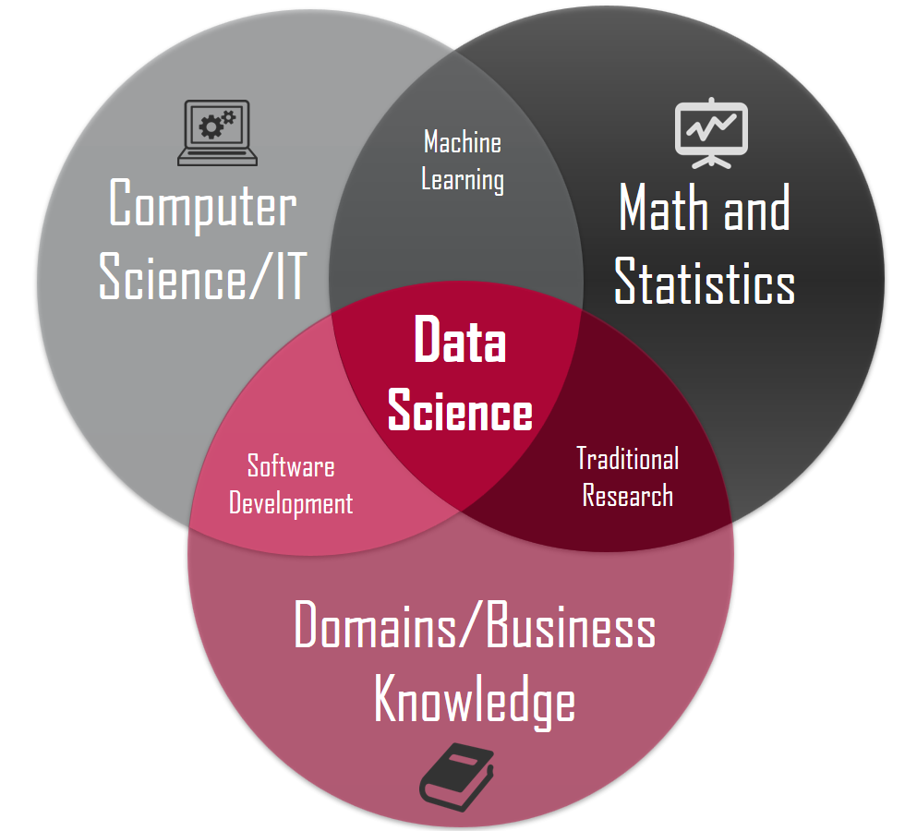
Why Climate Data Science?
Climate change is one of the biggest challenges of our time. Data scientists help by:
- Predicting weather patterns
- Understanding temperature trends
- Forecasting extreme events (floods, droughts, heatwaves)
- Supporting policy decisions with data-driven evidence
Real-World Climate Data Science Applications
- Weather Forecasting
  - Predicting rain, temperature, and wind patterns
  - Example: India Meteorological Department (IMD) daily forecasts
- Climate Change Analysis
  - Studying temperature rise over decades
  - Analyzing sea level changes
  - Example: IPCC climate reports use extensive data analysis
- Agricultural Planning
  - Predicting monsoon patterns for crop planning
  - Drought and flood risk assessment
  - Example: Farmers use rainfall predictions for planting schedules
- Disaster Management
  - Early warning systems for cyclones and floods
  - Risk mapping for vulnerable areas
  - Example: Cyclone tracking and evacuation planning
- Air Quality Monitoring
  - Tracking pollution levels
  - Predicting air quality index (AQI)
  - Example: Delhi air quality analysis and forecasting
Career Paths in Climate Data Science
Role | Description | Skills Needed
Climate Data Analyst | Analyze historical climate data to find trends | Python, Statistics, Data Visualization
Weather Prediction Engineer | Build models to forecast weather | Machine Learning, Deep Learning, Meteorology
Environmental Data Scientist | Study environmental impacts using data | Data Science, Domain Knowledge, GIS
Climate Research Scientist | Conduct research on climate patterns | Advanced Statistics, Research Methods, Programming
Sustainability Analyst | Help organizations reduce carbon footprint | Data Analysis, Business Understanding, Climate Science

Overview of the IMD Project
India Meteorological Department (IMD) provides daily weather data across India.
Our Project Goal: Analyze IMD climate data to:
- Understand temperature trends over time
- Predict rainfall patterns
- Identify extreme weather events
- Visualize climate changes in different regions of India
Data We'll Work With:
- Temperature (min, max, average)
- Rainfall (daily, monthly)
- Humidity
- Wind speed
- Pressure

2. Data Science Lifecycle
The Data Science Lifecycle is a step-by-step process for solving problems with data.
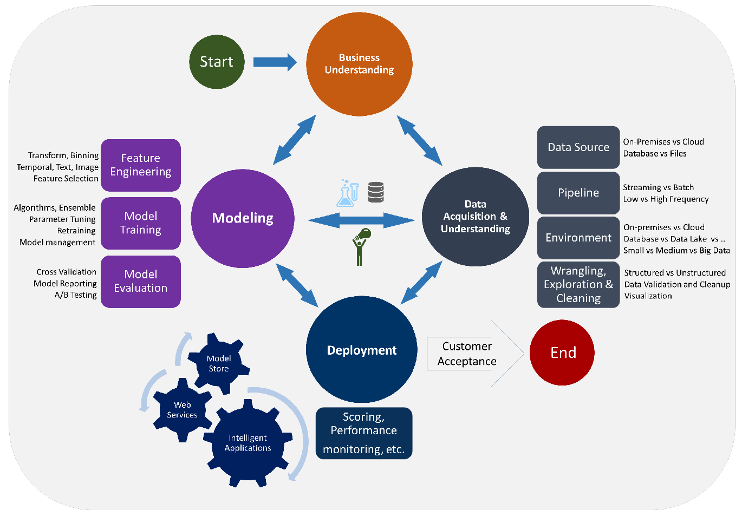
1. PROBLEM DEFINITION
↓
What question are we trying to answer?

2. DATA COLLECTION
↓
Where do we get the data?

3. DATA CLEANING
↓
Fix errors, handle missing values

4. EXPLORATORY DATA ANALYSIS (EDA)
↓
Understand patterns in data

5. FEATURE ENGINEERING
↓
Create new useful variables

6. MODEL BUILDING
↓
Train machine learning models

7. MODEL EVALUATION
↓
Test how well the model works

8. DEPLOYMENT
↓
Use the model in real-world applications

9. MONITORING
↓
Keep checking if the model still works well
Step 1: Problem Definition - Climate Research Questions
Before analyzing data, we must define clear questions.
Good Climate Research Questions:
- "Has the average temperature in Delhi increased over the last 50 years?"
- "Can we predict tomorrow's rainfall based on today's weather conditions?"
- "Which regions in India are experiencing more extreme heat events?"
- "How does monsoon timing vary across different states?"
Bad Questions (Too Vague):
- "What's happening with the weather?"
- "Tell me about climate change"
Framework for Good Questions:
- Specific: Clearly defined variables (temperature, rainfall)
- Measurable: Can be answered with data
- Achievable: Data is available
- Relevant: Matters to real-world decisions
- Time-bound: Has a specific time period
Step 2: Data Collection Methods for Weather/Climate
Sources of Climate Data:
- Government Agencies
  - India Meteorological Department (IMD)
  - National Oceanic and Atmospheric Administration (NOAA)
  - European Centre for Medium-Range Weather Forecasts (ECMWF)
- Weather Stations
  - Ground-based sensors measuring temperature, rainfall, pressure
  - Automated weather stations across cities
- Satellites
  - Remote sensing data
  - Cloud cover, sea surface temperature
  - Example: INSAT satellites by ISRO
- Research Datasets
  - Berkeley Earth (global temperature data)
  - NASA climate datasets
  - Kaggle climate competitions
Data Collection Methods:
python
# Example: Different ways to collect data

# Method 1: Download CSV files manually
# Visit IMD website → Download data → Save as CSV

# Method 2: API calls (Application Programming Interface)
import requests

url = "https://api.weather.com/data" # Example API
response = requests.get(url)
data = response.json()

# Method 3: Web Scraping
from bs4 import BeautifulSoup
import pandas as pd

# Scrape weather data from websites
# (Always check if scraping is allowed!)

# Method 4: Read from databases
import sqlite3

conn = sqlite3.connect('climate_data.db')
df = pd.read_sql_query("SELECT * FROM weather", conn)

Step 3: Model Building and Validation Overview
What is a Model? A model is a mathematical representation that learns patterns from data and makes predictions.
Types of Models for Climate Data:
- Regression Models (Predict continuous values)
  - Linear Regression: Predict temperature
  - Polynomial Regression: Capture non-linear trends
- Classification Models (Predict categories)
  - Logistic Regression: Will it rain today? (Yes/No)
  - Decision Trees: Classify weather as Sunny/Cloudy/Rainy
- Time Series Models (Predict future based on past)
  - ARIMA: Forecast next week's temperature
  - LSTM (Deep Learning): Long-term climate predictions
Model Building Process:
# Simplified example of building a model

# Step 1: Import libraries
from sklearn.model_selection import train_test_split
from sklearn.linear_model import LinearRegression
from sklearn.metrics import mean_squared_error

# Step 2: Prepare data
X = data[['humidity', 'pressure', 'wind_speed']] # Features
y = data['temperature'] # Target variable

# Step 3: Split data (80% training, 20% testing)
X_train, X_test, y_train, y_test = train_test_split(X, y, test_size=0.2)

# Step 4: Train model
model = LinearRegression()
model.fit(X_train, y_train)

# Step 5: Make predictions
predictions = model.predict(X_test)

# Step 6: Evaluate model
error = mean_squared_error(y_test, predictions)
print(f"Model Error: {error}")
Model Validation:
- Training Set: Data used to teach the model (80%)
- Test Set: Data used to check if model learned correctly (20%)
- Cross-Validation: Test multiple times with different splits
Evaluation Metrics:
- Accuracy: How often is the model correct?
- Mean Squared Error (MSE): Average of squared differences between predictions and actual values
- R² Score: How well does the model explain the data? (0 to 1, higher is better)

Interactive Discussion: What Questions Can We Answer with Climate Data?
Exercise: Think of 3 climate questions you'd like to answer
Example questions students might ask:
- Temperature Questions:
  - Is global warming affecting my city?
  - Which month is hottest in Mumbai?
  - Are winters getting warmer?
- Rainfall Questions:
  - When will monsoon arrive this year?
  - Which region gets most rainfall?
  - Are droughts becoming more common?
- Extreme Events:
  - How often do heatwaves occur?
  - Can we predict cyclones better?
  - Are floods increasing in frequency?
- Agricultural Impact:
  - Is rainfall enough for crops this season?
  - What's the best planting time based on weather?
- Health Impact:
  - How does temperature affect air quality?
  - Do heatwaves increase health risks?
Activity: Write down one climate question you're curious about. We'll try to answer it during this course!

Tools Setup & Version Control
1. Python Environment Setup
Why Python for Data Science?
Python is the most popular language for data science because:
- Easy to learn: Simple, readable syntax
- Powerful libraries: pandas, numpy, scikit-learn
- Large community: Lots of help available online
- Free and open-source: No license costs
What is Anaconda?
Anaconda is a distribution of Python that includes:
- Python interpreter
- Jupyter Notebook
- 250+ pre-installed data science packages
- Conda package manager
Download Link: https://www.anaconda.com/download
Step-by-Step Installation
https://www.youtube.com/watch?v=bkOEYmyMtEU
For Windows:
- Download Anaconda installer (exe file)
- Double-click to run
- Follow installation wizard
- Check "Add Anaconda to PATH" (optional but recommended)
- Click Install
Verifying Installation
Open Anaconda Prompt (Windows)
# Check Python version
python --version
# Output: Python 3.11.x or similar

Jupyter Notebook Introduction
What is Jupyter Notebook? An interactive environment where you can write code, see results immediately, and add explanations.
Starting Jupyter Notebook:

# Start Jupyter Notebook
jupyter notebook

# Browser will open automatically
# If not, copy the URL from terminal (http://localhost:8888/...)
```

**Jupyter Interface Tour:**

**Creating Your First Notebook:**

1. Click "New" → "Python 3"
2. Notebook opens in new tab
3. You'll see cells where you can write code
Cell Types:
- Code Cell: Write and run Python code
- Markdown Cell: Write text, explanations, formulas
Keyboard Shortcuts:
- Shift + Enter: Run cell and move to next
- Ctrl + Enter: Run cell and stay
- Esc: Enter command mode
- A: Insert cell above
- B: Insert cell below
- M: Change to Markdown cell
- Y: Change to Code cell
- DD: Delete cell
Installing Key Packages
bash
# Install data science packages
conda install pandas numpy matplotlib seaborn scikit-learn

# Alternative: Install specific versions
conda install pandas=2.0.0 numpy=1.24.0

# Install using pip (if conda doesn't have the package)
pip install package_name
Key Packages and Their Uses:
# In Jupyter Notebook, create a new cell and run:

# 1. pandas - Data manipulation and analysis
import pandas as pd
print(f"pandas version: {pd.__version__}")

# 2. numpy - Numerical computing
import numpy as np
print(f"numpy version: {np.__version__}")

# 3. matplotlib - Data visualization
import matplotlib.pyplot as plt
print(f"matplotlib version: {plt.matplotlib.__version__}")

# 4. seaborn - Statistical data visualization
import seaborn as sns
print(f"seaborn version: {sns.__version__}")

# 5. scikit-learn - Machine learning
import sklearn
print(f"scikit-learn version: {sklearn.__version__}")
Testing Your Setup:
python
# Create a simple visualization to test everything works

import pandas as pd
import matplotlib.pyplot as plt
import numpy as np

# Create sample climate data
dates = pd.date_range('2023-01-01', periods=365)
temperatures = 25 + 10 * np.sin(np.linspace(0, 2*np.pi, 365)) + np.random.randn(365) * 2

# Create DataFrame
df = pd.DataFrame({
'Date': dates,
'Temperature': temperatures
})

# Plot
plt.figure(figsize=(12, 5))
plt.plot(df['Date'], df['Temperature'], linewidth=2, color='orangered')
plt.title('Sample Temperature Data - Year 2023', fontsize=16, fontweight='bold')
plt.xlabel('Date', fontsize=12)
plt.ylabel('Temperature (°C)', fontsize=12)
plt.grid(True, alpha=0.3)
plt.tight_layout()
plt.show()

print("✓ All packages working correctly!")
print(f"✓ Total data points: {len(df)}")
print(f"✓ Average temperature: {df['Temperature'].mean():.2f}°C")
```
2. Git Basics for Data Science
**Why Version Control Matters**

Imagine you're writing a research paper:
- **Version 1**: First draft
- **Version 2**: Added results
- **Version 3**: Corrected errors
- **Version 4**: Final version

Without version control: `paper.doc`, `paper_final.doc`, `paper_final_v2.doc`, `paper_final_ACTUAL.doc` 😰

**With Git:**
- Track every change
- Go back to any previous version
- Work with team members without conflicts
- See who changed what and when

**Why Git for Data Science?**
- Track changes in code and notebooks
- Collaborate with other data scientists
- Share your work on GitHub
- Employers want to see your projects
- Reproduce results from past experiments

#### **What is Git vs GitHub?**

**Git**: Software for version control (runs on your computer)
**GitHub**: Website to store and share Git repositories online

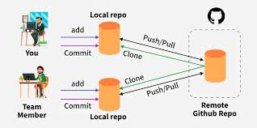

Installing Git
Windows:
- Download from: https://git-scm.com/download/win
- Run installer
- Use default settings
- Verify: Open "Git Bash" and type git –version
https://www.youtube.com/watch?v=t2-l3WvWvqg&t=34s –git installation

# Verify
git --version
Configuring Git (First Time Only)
bash
# Set your name (will appear in commits)
git config --global user.name "Your Name"

# Set your email
git config --global user.email "your.email@example.com"

# Check configuration
git config –list
Creating a GitHub Repository for the Project

🧠 Topic Overview
In this session, you’ll learn how to upload (push) an entire project folder from your local computer to your GitHub repository using Git Bash.
This is an essential skill for data scientists, developers, and students who want to back up their code online or collaborate with others.

🪜 Step-by-Step Procedure
Step 1: Open Your GitHub Account
- Go to https://github.com.
- Log in to your account.
- Click on “New Repository”.
- Give your repository a name (example: climate_data_project).
- Click Create Repository.
📌 After creation, GitHub will show you several commands — copy the one that looks like:
git remote add origin https://github.com/yourusername/ climate_data_project.git

Step 2: Open Git Bash in Your Local Folder
- Open your local file explorer.
- Choose the folder you want to upload (for example: git demo).
- Right-click inside the folder and select Git Bash Here.
This opens the Git Bash terminal in that folder.

Step 3: Initialize Git
git init
📝 This command converts your folder into a Git repository.

Step 4: Check File Status
git status
This shows which files are untracked, meaning Git has not yet added them for version control.

Step 5: Add Files to Git
git add .
✅ This adds all files from your folder into the staging area, ready for commit.

Step 6: Verify Status Again
git status
You’ll see your files in green, meaning they’re ready to be committed.

Step 7: Commit the Files
git commit -m "Initial commit – climate_data"
🧩 This command saves your changes locally with a message describing what you’ve done.

Step 8: Connect Local Repo to GitHub Repo
Paste the command you copied from GitHub:
git remote add origin https://github.com/yourusername/ climate_data_project.git

Step 9: Push Your Files to GitHub
git push origin main
💡 This uploads your local files to the GitHub repository.
If prompted, enter your GitHub username and password or authentication token.

Step 10: Verify Upload
- Go back to your GitHub repository page.
- Refresh the browser.
- 🎉 You’ll see your entire folder uploaded successfully!

🧩 Summary of Commands
Step | Command | Purpose
1 | git init | Initialize Git in the folder
2 | git status | Check which files are tracked/untracked
3 | git add . | Add all files to staging
4 | git commit -m "message" | Save a snapshot with a message
5 | git remote add origin <URL> | Link local folder to GitHub
6 | git push origin master | Upload files to GitHub

🎓 Class Discussion Prompts
- Why do we use git init before adding files?
- What’s the difference between git add and git commit?
- Why do we need git remote add origin?
- How can authentication issues occur during push?

🧠 Real-World Analogy
Think of Git as a personal assistant who tracks every version of your project:
- git add = telling your assistant what files to pack
- git commit = sealing the package
- git push = sending it to the online storage (GitHub)

💻 Homework/Practice
- Create a sample folder (e.g., my_first_repo).
- Add a few text or Python files inside.
- Follow all 10 steps above.
- Verify that your repository appears correctly on GitHub.

**Git Workflow Summary:**
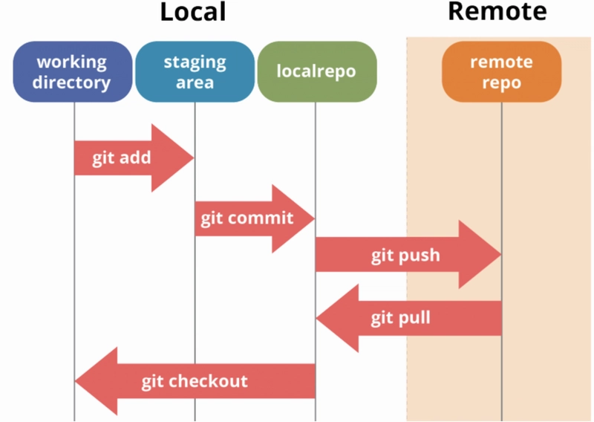
🧠 Topic: Pulling a Repository from GitHub
🔍 What Does “Pull” Mean?
- Pulling means downloading the latest version of a project (repository) from GitHub to your local computer.
- It keeps your local copy updated with any new changes made by others (or by you on another system).

🪜 Two Scenarios to Pull a Repository
Scenario 1: Cloning a Repository for the First Time
If you don’t have the repo yet on your computer, use git clone.
🧩 Step-by-Step:
- Go to GitHub
  - Open the repository you want to download.
  - Click on the green “Code” button → copy the HTTPS link.
Example:
  - https://github.com/yourusername/project_name.git
- Open Git Bash
  - Go to the folder where you want to download the project.
  - Right-click → select “Git Bash Here”.
- Run the Clone Command
- git clone https://github.com/yourusername/project_name.git
✅ This creates a new folder named project_name with all files inside it.
- Go Inside the Folder
- cd project_name

Scenario 2: Pulling Updates into an Existing Local Repo
If you already cloned the repository before, and now want to get the latest changes:
🧩 Step-by-Step:
- Navigate to Your Local Repo
- cd path/to/your/project_name
- Check Current Branch
- git branch
Usually, the default branch is main or master.
- Pull the Latest Changes
- git pull origin main
OR (if your branch is named master)
git pull origin master
✅ This updates your local folder with any new commits from GitHub.

🧰 Common Commands Summary
Command | Description
git clone <repo-url> | Download (clone) a GitHub repository for the first time
git pull origin main | Pull (update) the main branch
git branch | Check which branch you’re on
git status | See current changes and sync status

🧠 Analogy
Think of GitHub as Google Drive for your code:
- git clone → Download the folder for the first time
- git pull → Update your local folder when something changes online
- git push → Upload your new work back to the cloud

🏡 Homework Practice
- Find any public GitHub repository (e.g., from https://github.com/trending).
- Copy its HTTPS link.
- Open Git Bash and clone it using:
- git clone <repo-url>
- Modify one file (like README.md), then pull again to see if there are new changes.

Summary & Key Takeaways
What We Learned:
✓ Data Science in Climate: Understanding how data science helps solve climate problems
✓ Data Science Lifecycle: The step-by-step process from problem to solution
✓ Python Setup: Installed Anaconda, created environments, learned Jupyter Notebook
✓ Git Basics: Version control for tracking changes and collaboration
Action Items:
- ✅ Install Anaconda and verify installation
- ✅ Create climate_ds conda environment
- ✅ Test Jupyter Notebook with sample code
- ✅ Install Git and configure with your name/email
- ✅ Create GitHub account and repository
- ✅ Clone repository and set up project structure
Common Issues & Solutions:
Problem | Solution
Anaconda won't start | Restart computer after installation
conda command not found | Add Anaconda to PATH or use Anaconda Prompt
Jupyter notebook won't open | Check if another instance is running on port 8888
Git push requires password | Use personal access token instead of password
Import errors in Python | Make sure environment is activated
Resources for Further Learning:
- Python: https://docs.python.org/3/tutorial/
- Pandas: https://pandas.pydata.org/docs/user_guide/index.html
- Git: https://git-scm.com/doc
- Jupyter: https://jupyter-notebook.readthedocs.io/
- Climate Data: https://www.imdpune.gov.in/

Practice Exercises
Exercise 1: Environment Check
python
# Run this in Jupyter Notebook
import sys
import pandas as pd
import numpy as np
import matplotlib.pyplot as plt

print(f"Python version: {sys.version}")
print(f"Pandas version: {pd.__version__}")
print(f"NumPy version: {np.__version__}")
print("✓ Setup complete!")
Exercise 2: Your First Git Workflow
bash
# 1. Create a new file in your project
echo "Today I learned about Git!" > day1_notes.txt

# 2. Check status
git status

# 3. Add file
git add day1_notes.txt

# 4. Commit
git commit -m "Added Day 1 notes"

# 5. Push to GitHub
git push origin main
Exercise 3: Climate Question Write down 3 climate-related questions you'd like to answer with data. Think about:
- What interests you?
- What data would you need?
- How would answering this help people?

